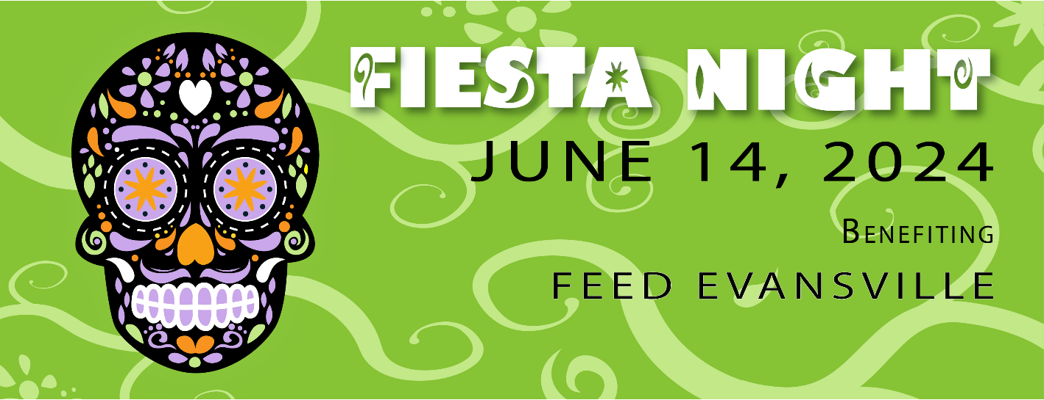

[Donor name and address]

Dear Donor name,

This year the Rotaract Club of Evansville celebrates our tenth annual Fiesta Night. A night filled with excitement, entertainment, camaraderie, and more. Last year, Fiesta Night raised over $5,000 to support The Children’s Museum of Evansville where Rotaract was able to sponsor three Family Free Nights where families who normally may not be able to access the museum can. Family Free Nights attract 400+ visitors, giving these children quality early learning and whole child development experiences.
This year all proceeds from Fiesta Night will benefit the 2024 Rotaract Signature Project, Feed Evansville.

Feed Evansville Feed Evansville has set a goal to place a Little Pantry in the 40% of Evansville Neighborhoods that are considered a food desert by the end of 2023. Little Pantries offer a zero-barrier access point to food to help fill the gaps in the food system. They support neighbors who are facing food insecurity while building micro-communities. They empower people to make an immediate change in their neighborhood.

I would like to invite you to the 2024 Rotaract Club of Evansville Fiesta Night on Friday, June 14th as a 2024 Signature Project sponsor. As a sponsor, you will be promoted on our social media channels leading up to the event, as well as recognized throughout the evening of Fiesta Night. This is our annual premier event that continues to grow both in size and excitement.

Thank you for your support of the Rotaract Club of Evansville and our 2024 Signature Project. Your commitment to our club allows us to continue our mission in the Evansville area.

Sincerely,

[Your Name]
Rotaract Club of Evansville

