Title Sponsor (1 available) $1,500
Eight (8) event tickets
Corporate logo incorporated into all 2024 Fiesta Night signage
Corporate name and logo identification at event and during PR events
Corporate name, logo, and link listed on Rotaract’s website and Facebook as Title Sponsor

Catering Sponsor (1 available) $1,250

Eight (8) event tickets
Corporate name and logo identification at event and during PR events
Extra signage on and around the catering tables
Corporate name, logo, and link listed on Rotaract’s website and Facebook as Catering Sponsor

Silent Auction Sponsor (1 available) $1,250

Eight (8) event tickets
Corporate name and logo identification at event and during PR events
Extra signage on and around the Silent Auction tables
Corporate name, logo, and link listed on Rotaract’s website and Facebook as Silent Auction Sponsor

Entertainment Sponsor (1 available) $1,000

Eight (8) event tickets
Corporate name and logo identification at event and during PR events
Extra signage on and around the photo booth and DJ tables
Corporate name, logo, and link listed on Rotaract’s website and Facebook as Entertainment Sponsor

Contact Name:________________________________ Phone Number:____________________________
Email Address: __________________________________________________________________________
Name as you would like it to appear in promotional materials:
________________________________________________________________________________________
Signature _______________________________________________________________________________
*Please email a high resolution copy of your logo to bcolvert@hotmail.com

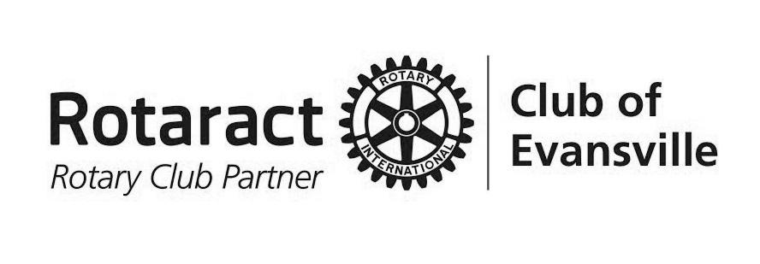
Please return Sponsorship Form to:
Rotaract Club of Evansville
P.O. Box 24, Evansville, IN 47701-0024
or bcolvert@hotmail.com

Thank you for your support of Rotaract’s Fiesta Night. Your sponsorship enables Rotaract to fulfill our mission of “Service before Self” which exemplifies the humanitarian spirit of our members and all fellow Rotarians.

