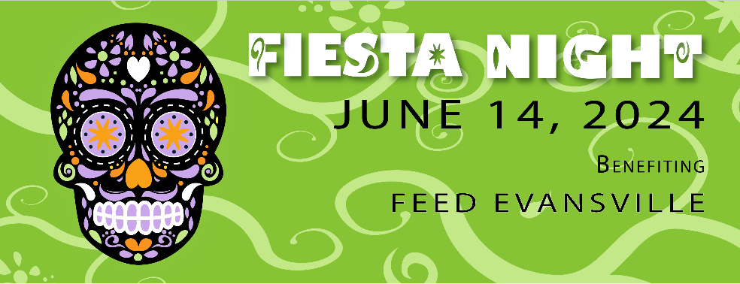

Matador Level $750

Eight (8) event tickets
Corporate name and logo* identification at event and during PR events
Corporate name, logo, and link listed on Rotaract’s website and Facebook as an event sponsor
Additional tickets for $20 each Number of additional tickets: ______

Mariachi Band Level $500

Four (4) event tickets
Corporate name and logo* identification at event
Corporate name and logo listed on Rotaract’s website and Facebook as an event sponsor
Additional tickets for $20 each Number of additional tickets: ______

Sombrero Level $250

Two (2) event tickets
Corporate name identification at event.
Corporate name listed on Rotaract’s website and Facebook as an event sponsor.
Additional tickets for $20 each Number of additional tickets: ______

Contact Name:_________________________ Phone Number:_______________________
Email Address: _____________________________________________________________
Name as you would like it to appear in promotional materials:
__________________________________________________________________________
Signature __________________________________________________________________
*Please email a high resolution copy of your logo to bcolvert@hotmail.com
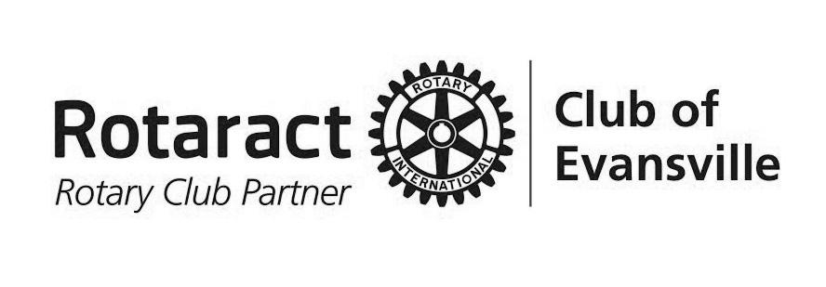
Please return Sponsorship Form and payment to:
Rotaract Club of Evansville
P.O. Box 24, Evansville, IN 47701-0024
or bcolvert@hotmail.com

Thank you for your support of Rotaract’s Fiesta Night. Your sponsorship enables Rotaract to fulfill our mission of “Service before Self” which exemplifies the humanitarian spirit of our members and all fellow Rotarians.

